Experiment 2

Analysis of SWR (Standing Wave Ratio) pattern in High Frequency Transmission Lines by varying a) load impedance b) Characteristic impedance

Test case-1
Code-
clc;
clear;
close;
Zo = 50;
ZR = 75 - (%i * 25);
K = (ZR - Zo) / (ZR + Zo);
ampK = abs(K);
S = (1 + ampK) / (1 - ampK);
printf("\nReflection Coefficient = %f + %fi", real(K), imag(K));
printf("\nMagnitude of Reflection Coefficient = %f", ampK);
printf("\nStanding Wave Ratio (SWR) = %f", round(S * 1000) / 1000);

Output:
Z0=50 ohms variable ZR

Characteristics Impedance | Simulation Result  SWR | Theoretical Result  SWR
50 | 1.768 | 1.77
50 | 1.808 | 1.819

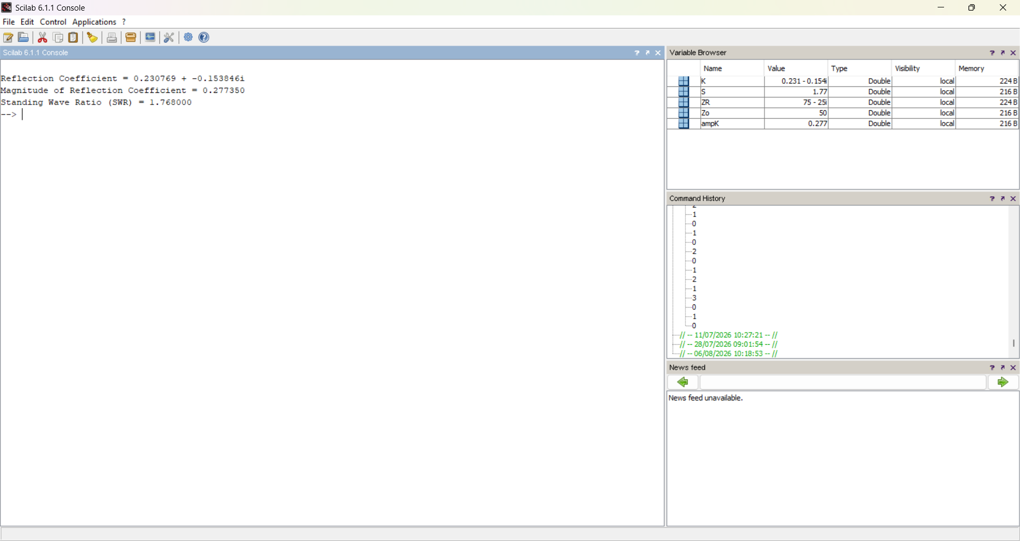

ZR=50/40 ohms variable Z0

Characteristics Impedance | Simulation Result  SWR | Theoretical Result  SWR
60 | 1.539 | 1.602
50 | 1.419 | 1.562
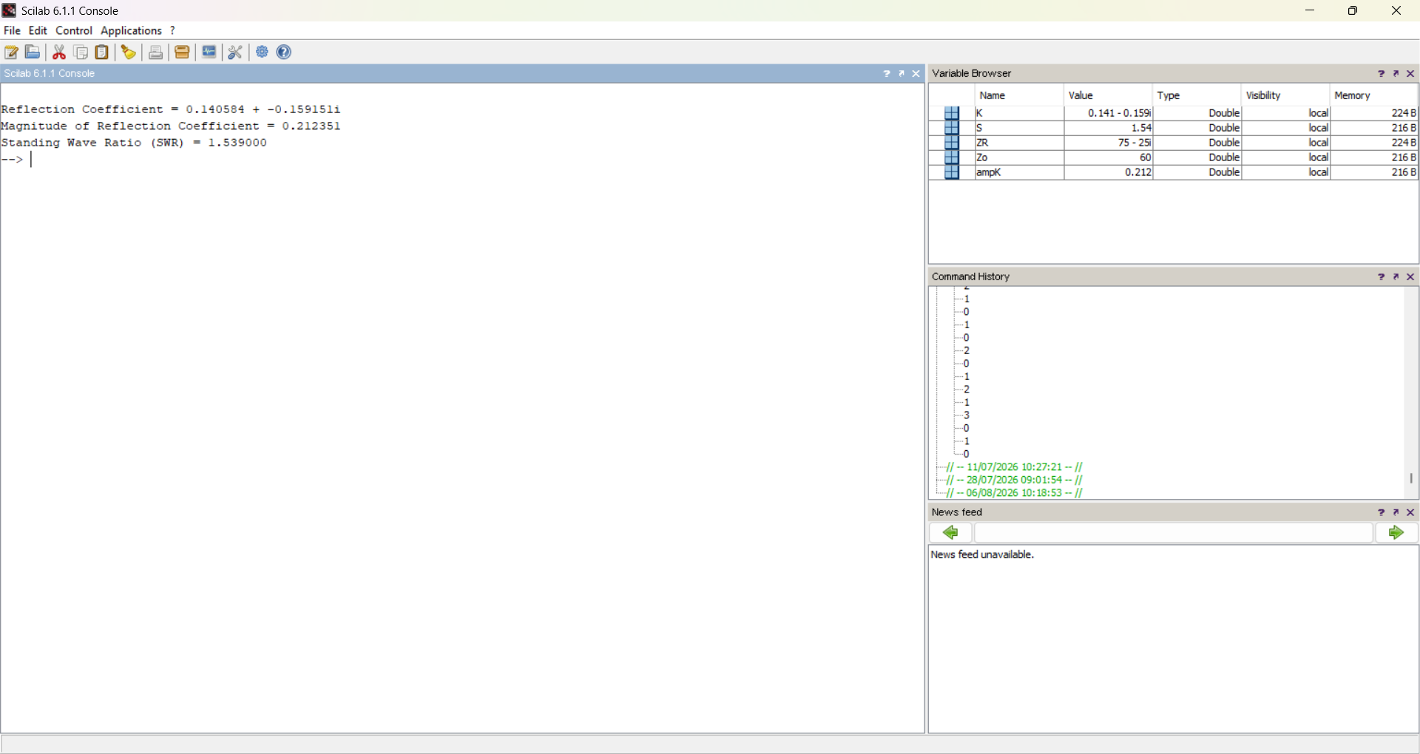

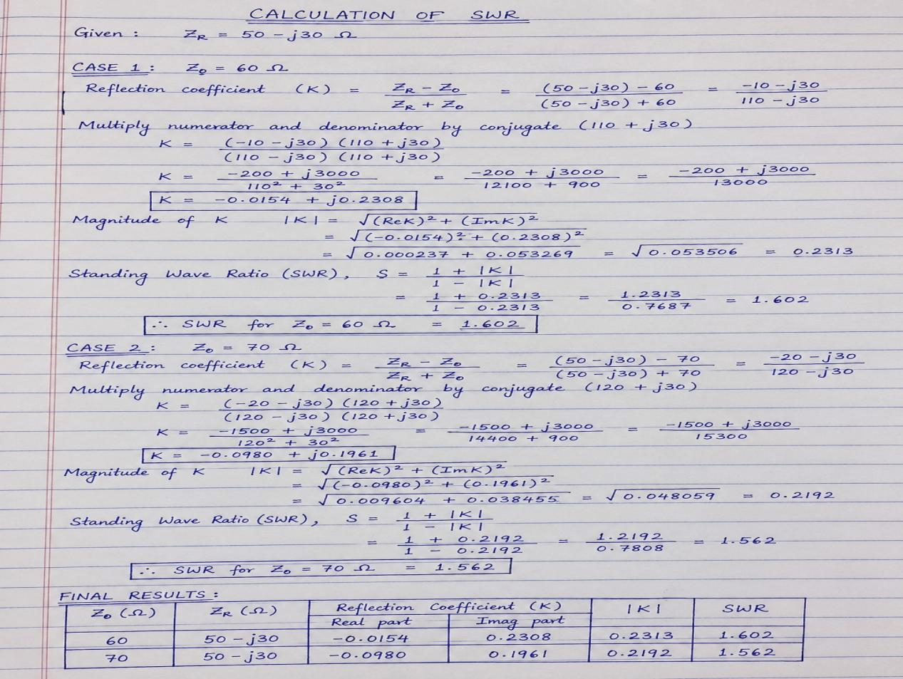
Test Case 2:
Code-

clc;
clear;close;
Zo=200;ZR=650-(%i*475);
K=(ZR-Zo)/(ZR+Zo);
ampK=sqrt((real(K)^2)+(imag(K)^2));
S=(1+ampK)/(1-ampK);
printf("(c)Standing wave ratio = %f",round(S*1000)/1000);

Output:

ZR=50/40 ohms variable Z0

Characteristics Impedance | Simulation Result  SWR | Theoretical Result  SWR
200 | 5.09 | 5.03
50 | 3.500 | 3.56

